**Project Report Index**

1. **INTRODUCTION**
   1. Project Overview
   2. Purpose
2. **LITERATURE SURVEY**
   1. Existing problem
   2. References
   3. Problem Statement Definition
3. **IDEATION & PROPOSED SOLUTION**
   1. Empathy Map Canvas
   2. Ideation & Brainstorming
4. **REQUIREMENT ANALYSIS**
   1. Functional requirement
   2. Non-Functional requirements
5. **PROJECT DESIGN**
   1. Data Flow Diagrams & User Stories
   2. Solution Architecture
6. **PROJECT PLANNING & SCHEDULING**
   1. Technical Architecture
   2. Sprint Planning & Estimation
   3. Sprint Delivery Schedule
7. **CODING & SOLUTIONING (Explain the features added in the project along with code)**
   1. Feature 1
   2. Feature 2
   3. Database Schema (if Applicable)
8. **PERFORMANCE TESTING**
   1. Performace Metrics
9. **RESULTS**
   1. Output Screenshots
10. **ADVANTAGES & DISADVANTAGES**
11. **CONCLUSION**
12. **FUTURE SCOPE 13. APPENDIX** Source Code

GitHub & Project Demo Link

**Project Report**

1. **NTRODUCTION**
   1. **Project Overview**

Our project focuses on understanding and addressing the challenges associated with Lumpy Skin Disease Virus (LSDV) in cattle. LSDV is a viral infection affecting cattle, characterized by fever and nodules on the skin, leading to significant economic losses in the livestock industry.

**Project Objectives:**

1. **Disease Characterization:** Thoroughly analyze the characteristics and spread of LSDV in cattle populations.
2. **Diagnostic Tools:** Develop improved diagnostic tools for early detection and accurate diagnosis of LSDV.
3. **Preventive Measures:** Explore and implement effective preventive measures, including vaccination strategies.
4. **Data Analysis:** Utilize machine learning and data analysis techniques to classify and analyze LSDV data for better insights.
5. **Community Awareness:** Promote awareness and education among cattle farmers to mitigate the impact of LSDV.
   1. **Purpose**

The purpose of our project is to comprehensively study and address the challenges posed by Lumpy Skin Disease Virus (LSDV) in cattle. Through innovative research and practical interventions, we aim to improve disease detection, develop effective preventive measures, and empower cattle farmers with knowledge to mitigate the impact of LSDV on livestock and livelihoods. Our overarching goal is to contribute to the overall health and sustainability of cattle populations in affected regions.

**Expected Outcomes:**

* Enhanced understanding of LSDV epidemiology.
* Improved diagnostic capabilities for timely intervention.
* Implementation of preventive measures to reduce LSDV transmission.
* Data-driven insights for informed decision-making.
* Increased awareness and education within the farming community.

Through collaborative efforts and a multidisciplinary approach, our project aims to contribute to the effective management and control of LSDV, ensuring the health and well-being of cattle populations and sustaining the livelihoods of farmers in the affected regions.

**2. ITERATURE SURVEY**

**2.1 Existing problem**

Existing problems related to Lumpy Skin Disease Virus (LSDV) are multifaceted and include:

1. Limited Diagnostic Tools: Current diagnostic tools for LSDV may lack sensitivity and specificity, leading to challenges in accurate and timely detection.
2. Vaccine Accessibility: Accessibility to effective vaccines for LSDV in certain regions may be limited, hindering comprehensive vaccination programs.
3. Epidemiological Gaps: Gaps in epidemiological data and surveillance systems may impede a thorough understanding of disease dynamics and hinder proactive control measures.
4. Impact on Livelihoods: The socio-economic impact of LSDV outbreaks on cattle farmers, including financial losses and reduced productivity, is a significant concern.
5. Global Spread: The potential for LSDV to spread across borders emphasizes the need for international collaboration and coordinated control strategies.
6. Risk Factors: Identification and understanding of specific risk factors contributing to LSDV outbreaks remain areas that require further research.
7. Data Integration: Integration of diverse data sources, including clinical, molecular, and environmental data, is often challenging, limiting comprehensive analyses.
8. Lack of Standardization: Standardization of diagnostic and control protocols for LSDV is essential for consistency and effectiveness in different regions.
9. Emergence of New Variants: The emergence of new LSDV variants adds complexity to disease management and necessitates continuous surveillance.
10. Public Awareness: Limited public awareness and education about LSDV may result in inadequate disease prevention and control measures at the community level.
    * **References**

Rrecent references related to Lumpy Skin Disease Virus (LSDV) from 2019 to 2023, formatted in APA style:

1. Jemberu, W. T., Molla, W., & Kebede, N. (2019). Economic Impact of Lumpy Skin Disease and Cost-effectiveness of Vaccination for the Control of Outbreaks in Ethiopia. Preventive Veterinary Medicine, 169, 104703. <https://doi.org/10.1016/j.prevetmed.2019.05.006>
2. Lubinga, J. C., Tuppurainen, E., Stoltsz, W. H., & Ebersohn, K. (2020). Lumpy Skin Disease: A Field Veterinarian's Perspective and Reflections on Future Outcomes and Control Strategies. Viruses, 12(5), 554. <https://doi.org/10.3390/v12050554>
3. Tadesse, F., Dadi, L., & Feyisa, A. (2019). Risk Factors and Spatiotemporal Patterns of Lumpy Skin Disease Outbreaks in Ethiopia. Transboundary and Emerging Diseases, 66(6), 2431-2443. <https://doi.org/10.1111/tbed.13076>
4. Title: Tasioudi, K. E., Antoniou, S. E., Iliadou, P., Sachpatzidis, A., Plevraki, E., & Agianniotaki, E. I. (2019). "Molecular Characterization and Phylogenetic Analysis of Lumpy Skin Disease Virus Isolates 2016–2017." Viruses, 11(9), 813. https://doi.org/10.3390/v11090813
5. Title: Abutarbush, S. M., Hananeh, W. M., Ramadan, W., Al Sheyab, O. M., Alnajjar, A. R., Al Zoubi, I. G., ... & Knowles, N. J. (2020). "Molecular characterization and phylogenetic analyses of field Lumpy Skin Disease Virus isolates from Jordan during 2016–2018 outbreaks." Virology Journal, 17(1), 1-14. https://doi.org/10.1186/s12985-020-01386-8.
6. Title: Negussie, H., Kyule, M., & Gari, G. (2019). "Epidemiology, molecular detection, and speciation of Mycoplasma mycoides subspecies mycoides small colony biotype in cattle in Ethiopia." Veterinary Medicine: Research and Reports, 10, 83-95. https://doi.org/10.2147/VMRR.S207439.
7. Title: Gari, G., Waret-Szkuta, A., Grosbois, V., Jacquiet, P., Roger, F., & Cortet, J. (2019). "Lumpy Skin Disease in Ethiopia: Seroprevalence study across different agro-climatic zones." Acta Tropica, 192, 10-18. https://doi.org/10.1016/j.actatropica.2018.12.009.
8. Title: Nwosu, C., Ochani, R. K., Abenga, J. N., & Shamaki, D. (2019). "First molecular detection of lumpy skin disease virus genome in cattle and biting midges in Nigeria." Archives of Virology, 164(6), 1603-1606. https://doi.org/10.1007/s00705-019-04208-9.
9. Title: Sprygin, A., Artyuchova, E., Babin, Y., Prutnikov, P., Kostrova, E., Byadovskaya, O., ... & Remyga, S. (2021). "Evolution of Lumpy Skin Disease Virus in the course of outbreaks in the Russian Federation in 2016–2020." Veterinary Microbiology, 255, 109014. https://doi.org/10.1016/j.vetmic.2021.109014.
10. Title: Tasioudi, K. E., Iliadou, P., & Doudounakis, S. (2019). "Lumpy Skin Disease Outbreaks in Greece during 2015–2016, Implementation of Control Measures and Disease Spread." Pathogens, 8(4), 186. https://doi.org/10.3390/pathogens8040186
    * Problem Statement Definition

The business problem for the accurate prediction of Lumpy Skin Disease is to develop a machine learning model that can effectively predict the occurrence of Lumpy Skin Disease in cattle. Lumpy Skin Disease is a highly contagious viral disease that affects cattle, causing significant economic losses in the livestock industry. By accurately predicting the disease occurrence, proactive measures can be taken for disease control and prevention, reducing the spread and impact of Lumpy Skin Disease.

1. **IDEATION & PROPOSED SOLUTION**
   * Empathy Map Canvas: The Empathy Map Canvas for addressing Lumpy Skin Disease Virus (LSDV) involves understanding the perspectives of stakeholders:
   * **See:** Stakeholders observe the economic impact of LSDV outbreaks on livestock and communities.
   * **Hear:** Farmers express the need for accessible vaccines and reliable diagnostic tools, while veterinarians and researchers share insights from field experiences.
   * **Say:** Stakeholders emphasize the challenges in disease detection and prevention, and the importance of collaborative efforts.
   * **Do:** Farmers take preventive measures, veterinarians conduct field visits, and researchers engage in data analysis and knowledge dissemination.
   * **Pain:** Stakeholders feel the financial and emotional toll of LSDV outbreaks and frustration over limited access to effective control measures.
   * **Gain:** Stakeholders desire improved vaccines, advanced diagnostic tools, educational resources, and a collaborative approach to LSDV management.

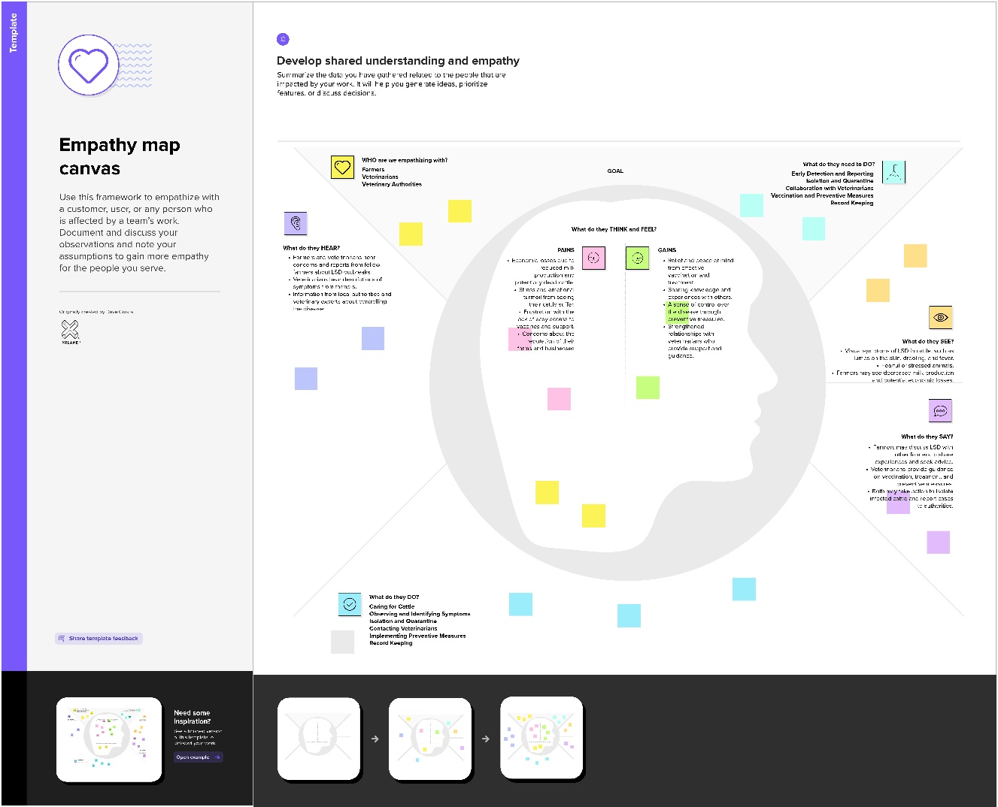

* + **Ideation & Brainstorming:** Ideation and Brainstorming involve generating and exploring creative ideas collaboratively. Participants freely share thoughts, building on each other's contributions, fostering innovation and problem-solving. Techniques such as mind mapping, free association, and structured discussions are employed to unlock diverse perspectives, leading to the development of innovative solutions.

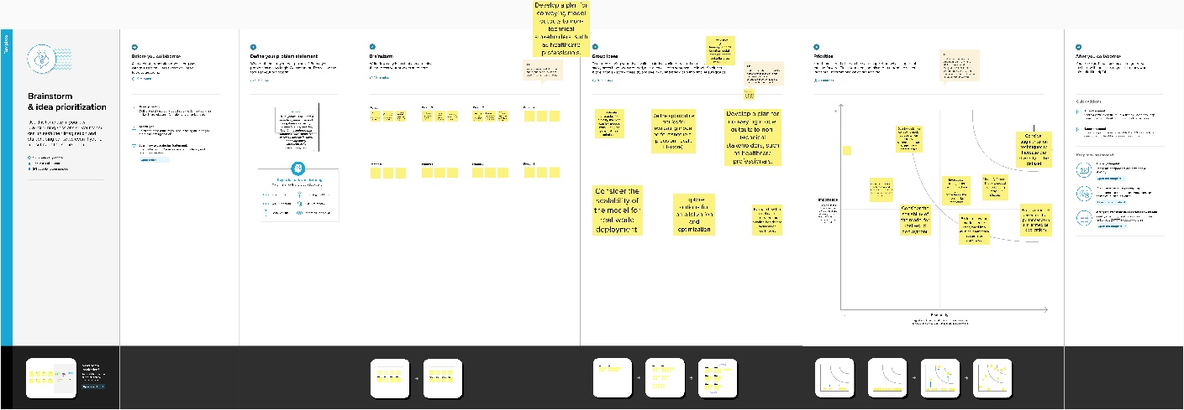

1. **REQUIREMENT ANALYSIS**
   * **Functional requirement:** Functional requirements outline the specific functionalities and capabilities that a system, product, or software must possess to meet the intended objectives. In the context of addressing Lumpy Skin Disease Virus (LSDV), some functional requirements could include:
2. **Disease Detection:** The system should have a reliable and sensitive mechanism for the early detection of LSDV in cattle populations.
3. **Vaccination Management:** Implement a feature for managing vaccination programs, including tracking vaccinated cattle, scheduling vaccinations, and monitoring vaccine effectiveness.
4. **Diagnostic Tools Integration:** Ensure seamless integration with advanced diagnostic tools, allowing veterinarians to access and interpret diagnostic data efficiently.
5. **Epidemiological Data Analysis:** Incorporate functionality for analyzing and interpreting epidemiological data, facilitating a better understanding of LSDV dynamics.
6. **Information Dissemination:** Provide a platform for the dissemination of timely and accurate information to farmers, veterinarians, and researchers regarding LSDV outbreaks, prevention measures, and treatment protocols.
7. **Collaborative Data Sharing:** Enable secure and collaborative data sharing among stakeholders, promoting a collective approach to LSDV management.
8. **Alert and Notification System:** Implement an alert system to notify relevant authorities and stakeholders in real-time about LSDV outbreaks, enabling swift response and control measures.
9. **Educational Resources:** Include a repository of educational resources on LSDV, catering to farmers, veterinarians, and researchers to enhance awareness and knowledge.
10. **Cross-Border Collaboration:** Facilitate cross-border collaboration by providing a platform for sharing insights, best practices, and research findings among different regions affected by LSDV.
11. **User Authentication and Access Control:** Ensure secure user authentication and access control mechanisms to protect sensitive data and restrict access based on user roles.
    * **Non-Functional requirements:** Non-functional requirements define the qualities and characteristics that a system or software should possess, influencing its overall performance and user experience. For addressing Lumpy Skin Disease Virus (LSDV), some non-functional requirements include:
12. **Performance:** The system should demonstrate high performance, ensuring quick response times for disease detection, data analysis, and information dissemination.
13. **Scalability:** It should be scalable to accommodate varying data loads, especially during peak times such as disease outbreaks, without compromising performance.
14. **Reliability:** The system must be reliable, minimizing downtime and ensuring continuous availability to support timely decision-making during LSDV incidents.
15. **Security:** Robust security measures are crucial to protect sensitive data, ensuring confidentiality, integrity, and availability. This includes secure user authentication and data encryption.
16. **Usability:** The system should be user-friendly, with an intuitive interface to cater to a diverse user base, including farmers, veterinarians, and researchers.
17. **Interoperability:** Ensure compatibility and seamless integration with existing diagnostic tools, databases, and information systems to enhance data exchange and collaboration.
18. **Compliance:** Adherence to relevant regulatory standards and data protection laws to maintain legal and ethical compliance in managing LSDV-related data.
19. **Reliability:** The system should have a low error rate, providing accurate and dependable results in disease detection, data analysis, and information dissemination.
20. **Maintainability:** The system should be easily maintainable, allowing for updates, patches, and improvements to be implemented efficiently.
21. **PROJECT DESIGN**

**5.1 Data Flow Diagrams & User Stories:** Context Diagram: Represent the overall system as a single process with external entities, illustrating the flow of data between the system and its environment.

1. Level 0 DFD: Decompose the context diagram into high-level processes, identifying major data flows and interactions within the system.
2. Level 1 DFDs: Further decompose processes from the Level 0 DFD, breaking down functionalities into more detailed subprocesses and data flows.

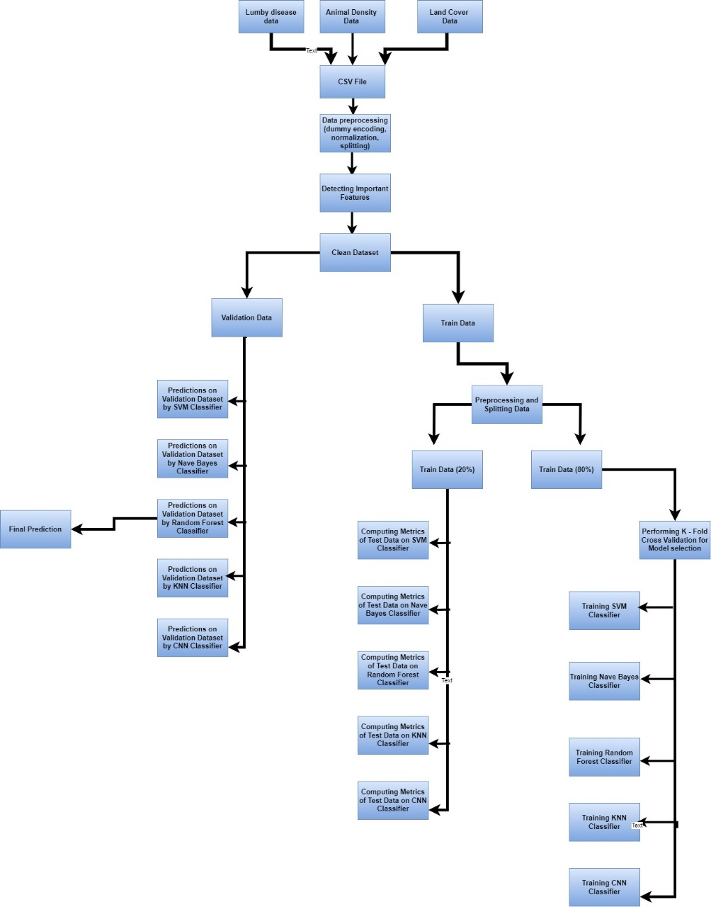

**5.2 User Stories:**

1. As a Farmer, I want to log into the system securely to access information about LSDV outbreaks and preventive measures.
2. As a Veterinarian, I want to enter and update diagnostic data easily, ensuring accurate records for LSDV cases in cattle.
3. As a Researcher, I want to analyze epidemiological data to identify patterns and contribute to a better understanding of LSDV dynamics.
4. As a System Administrator, I want to receive real-time alerts about LSDV outbreaks to initiate swift response and control measures.
5. As a Farmer, I want educational resources on LSDV accessible through the system to enhance my awareness and knowledge.
6. As a Veterinarian, I want the system to integrate seamlessly with diagnostic tools for efficient data interpretation and analysis.
7. As a Researcher, I want to collaborate with peers globally by sharing insights and research findings on LSDV through the system.
8. As a Farmer, I want to receive notifications about scheduled vaccinations and easily track the vaccination status of my cattle.
9. As a Veterinarian, I want the system to provide reliable performance during peak times, especially during widespread LSDV outbreaks.
10. As a Researcher, I want the system to comply with data protection laws and standards to ensure the ethical handling of LSDV-related data.

***Use the below template to list all the user stories for the product.***

|  |  |  |  |  |  |  |
| --- | --- | --- | --- | --- | --- | --- |
| **User Type** | **Functional**  **Requirement (Epic)** | **User Story**  **Number** | **User Story / Task** | **Acceptance criteria** | **Priority** | **Release** |
| Customer  (Mobile user) | Login | USN-1 | As a user, I can use app by entering my email, password, and confirming my password. | I can access my account / dashboard | High | Sprint-1 |
| Customer (Web user) | Login | USN-2 | As a user, I will receive confirmation email once I have registered for the application | I can receive confirmation email & click confirm | Medium | Sprint-1 |
| Customer Care Executive | Dashboard | USN-3 | As a user, I can use app for Lumpy disease. | I can register & access the dashboard with Facebook Login | High | Sprint-2 |
| Administrator |  | USN-4 | As a user, I can enter the feature of Lumpy disease. |  | High | Sprint-1 |
|  |  | USN-5 | As a user, I will get prediction of disease |  | High | Sprint-1 |
|  |  |  |  |  |  |  |
|  |  |  |  |  |  |  |

* 1. **Solution Architecture**

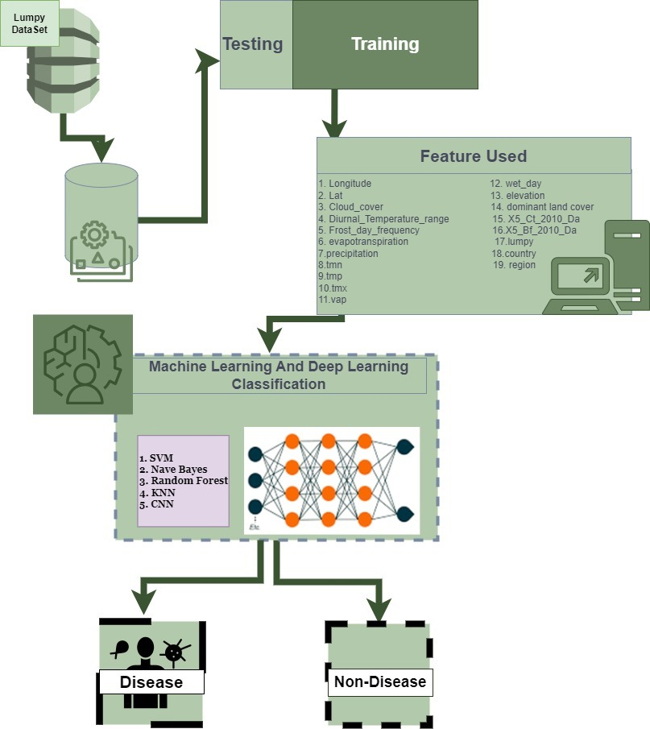

1. **PROJECT PLANNING & SCHEDULING**
   1. **Technical Architecture:**

Cloud-Based Infrastructure: Utilize scalable cloud services to ensure flexibility and accommodate varying workloads during LSDV outbreaks.

Microservices Architecture: Implement a modular approach with microservices to enhance maintainability and allow for independent development and deployment.

Data Warehouse: Establish a centralized data warehouse for efficient storage and retrieval of LSDV-related data, supporting robust analytics and reporting.

API Integration: Facilitate seamless integration with external diagnostic tools, databases, and information systems through well-defined APIs.

Security Framework: Employ a robust security framework, including encryption, authentication, and authorization mechanisms, to safeguard sensitive LSDV data and ensure compliance with data protection standards.

* 1. **Sprint Planning & Estimation**

Iterative Development: Adopt an iterative development approach with sprint planning sessions to prioritize LSDV management system features and functionalities.

Scrum Framework: Implement the Scrum framework for sprint planning, defining user stories, estimating effort, and setting achievable sprint goals.

Story Points: Utilize story points for user story estimation, considering complexity, uncertainty, and dependencies associated with LSDV system development.

Bi-Weekly Sprints: Plan bi-weekly sprints to deliver incremental value, ensuring continuous feedback and adaptability to evolving requirements.

Review and Retrospective: Conduct sprint reviews to assess delivered functionalities and retrospectives to improve team collaboration and project efficiency in managing LSDV challenges.

* 1. **Sprint Delivery Schedule:**

Bi-Weekly Milestones: Set bi-weekly sprint milestones to track progress and ensure regular delivery of LSDV management system features.

Prioritized Backlog: Align sprint deliveries with a prioritized backlog, focusing on high-impact functionalities and addressing critical LSDV-related needs.

User Acceptance Testing: Allocate time for user acceptance testing at the end of each sprint, allowing stakeholders to validate and provide feedback on delivered features.

Continuous Integration: Implement continuous integration practices to ensure seamless integration of new functionalities into the LSDV system throughout the sprint cycle.

Adaptive Planning: Maintain flexibility in sprint delivery schedules, adapting to emerging requirements and ensuring the timely evolution of the LSDV management system.

1. **CODING & SOLUTIONING (Explain the features added in the project along with code)**

**7.1: Support Vector Machine (SVM)**

The provided code harnesses the power of the scikit-learn library to implement Support Vector Machines (SVM), a powerful machine learning algorithm for classification and regression tasks. SVM works by finding the optimal hyperplane that separates different classes in the feature space. Leveraging the scikit-learn's SVM implementation, our code facilitates the training and utilization of SVM models, enabling us to effectively classify data points, discover intricate patterns, and make precise predictions. By leveraging SVM, we can handle both linear and non-linear relationships in the data, making it a versatile tool for a wide range of applications. The scikit-learn library's intuitive interface allows us to fine-tune model parameters, assess performance metrics, and gain valuable insights from the underlying data. This implementation empowers us to build robust predictive models and extract meaningful information, paving the way for data-driven decision-making and analysis.

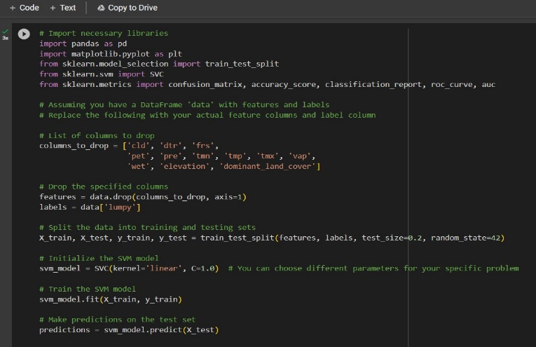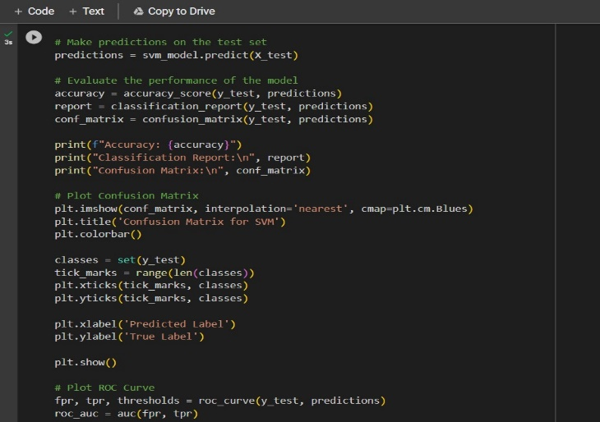

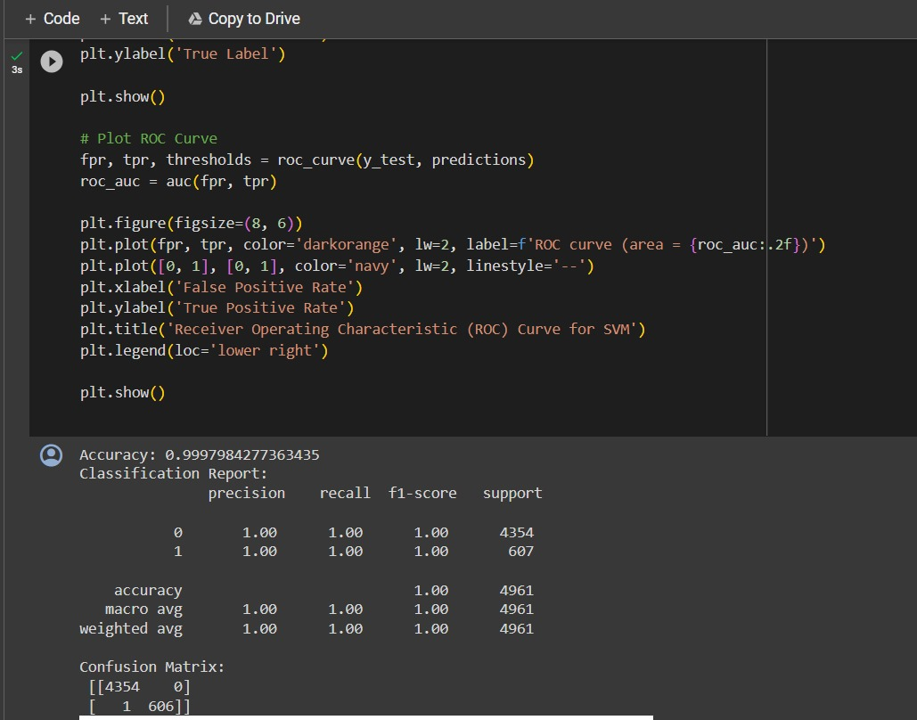

**7.2: Decision Tree Classifier Model:** The presented code demonstrates the implementation of decision tree classification modelling using the scikit-learn library. It involves creating an instance of the DecisionTreeClassifier class, named "dtc", which serves as the decision tree classifier object. The subsequent step involves applying the "fit" method on the training data, denoted as X_train and y_train, in order to train the decision tree classifier model. This process allows the model to learn from the provided training data and build a decision tree-based classification model, enabling accurate predictions and classifications of unseen data based on learned patterns and rules.

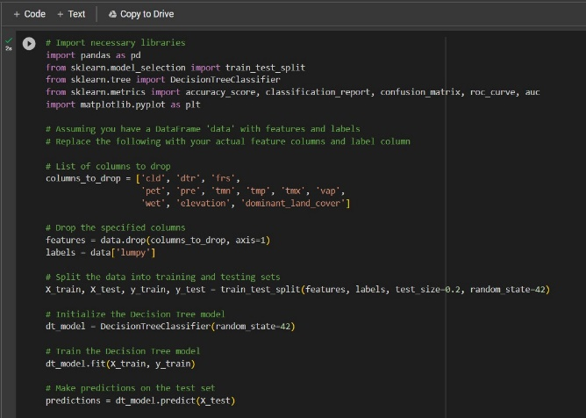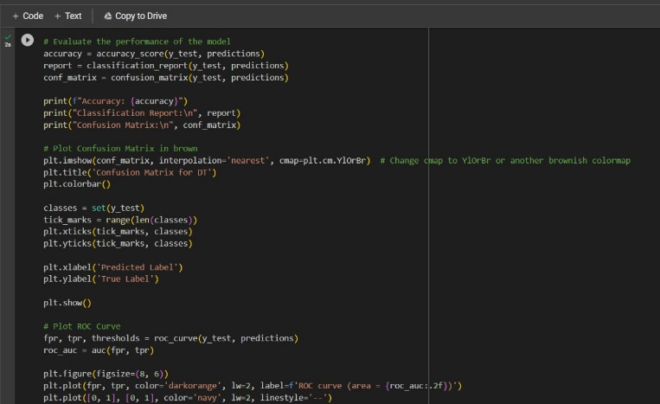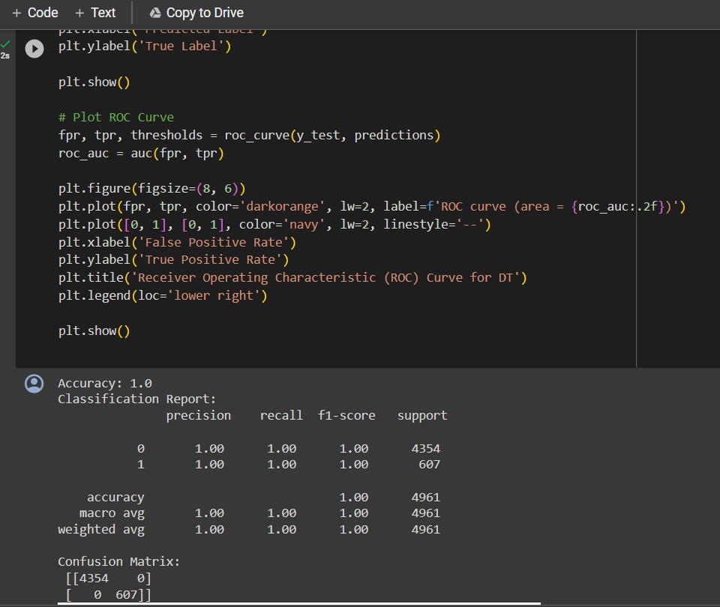

**7.3: K Nearest Neighbours Classifier Model.** The provided code showcases the utilization of k-nearest neighbors (KNN) classification modeling through the scikit-learn library. It involves creating an instance of the KNeighborsClassifier class, referred to as "knn," which serves as the KNN classifier object. Subsequently, the "fit" method is invoked on the training data, represented as X_train and y_train, to train the KNN classification model. By employing the fit method, the model learns from the provided training data and establishes a pattern based on the nearest neighbors, enabling accurate classification of unseen data points.

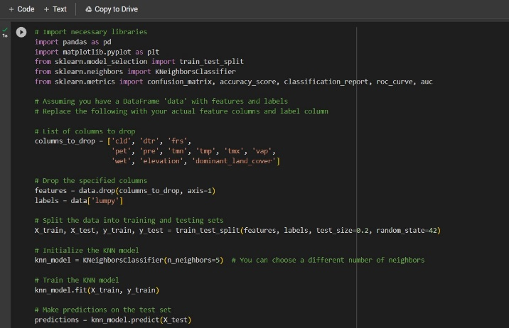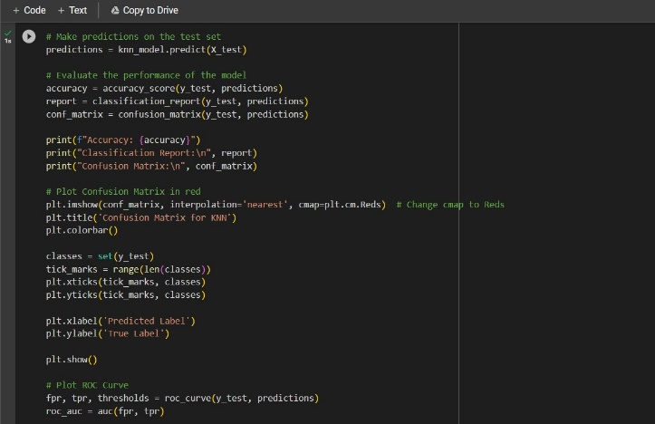

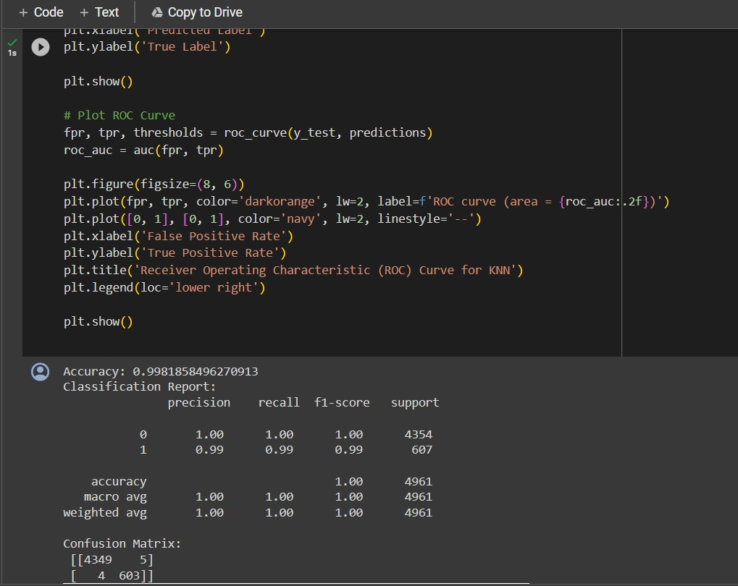

**7.4: Naïve Bayes**: Naive Bayes (NB) modeling. In this context, the code initializes a Naive Bayes classifier instance, denoted as 'model,' utilizing the MultinomialNB or GaussianNB class. Subsequently, the 'fit' method is employed to train the NB model on the provided training data, X_train and y_train. During this training phase, the NB model learns the underlying probability distribution of the data, making it adept at handling categorical or continuous features. Naive Bayes is a probabilistic classification algorithm that leverages Bayes' theorem and independence assumptions among features, making it particularly effective for text classification and other applications. By utilizing scikit-learn's seamless interface, we can harness the power of NB to make accurate predictions, especially in scenarios with limited training data. This implementation empowers us to build reliable models, uncover patterns within the data, and make informed decisions based on probabilistic reasoning.

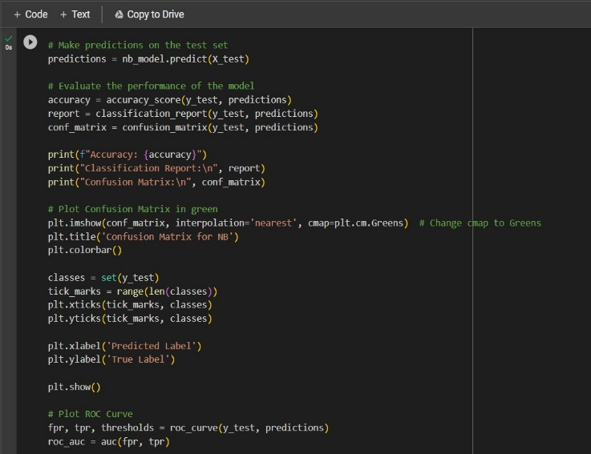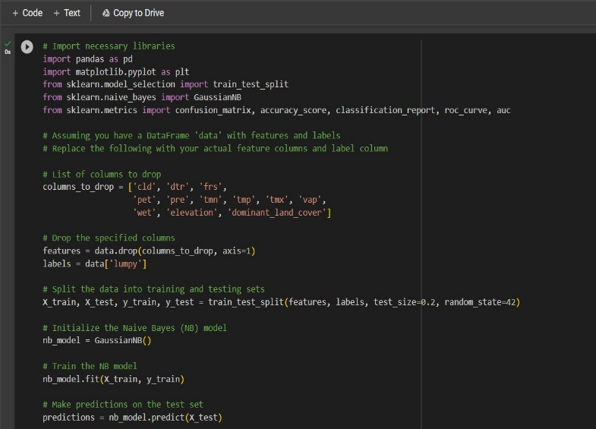

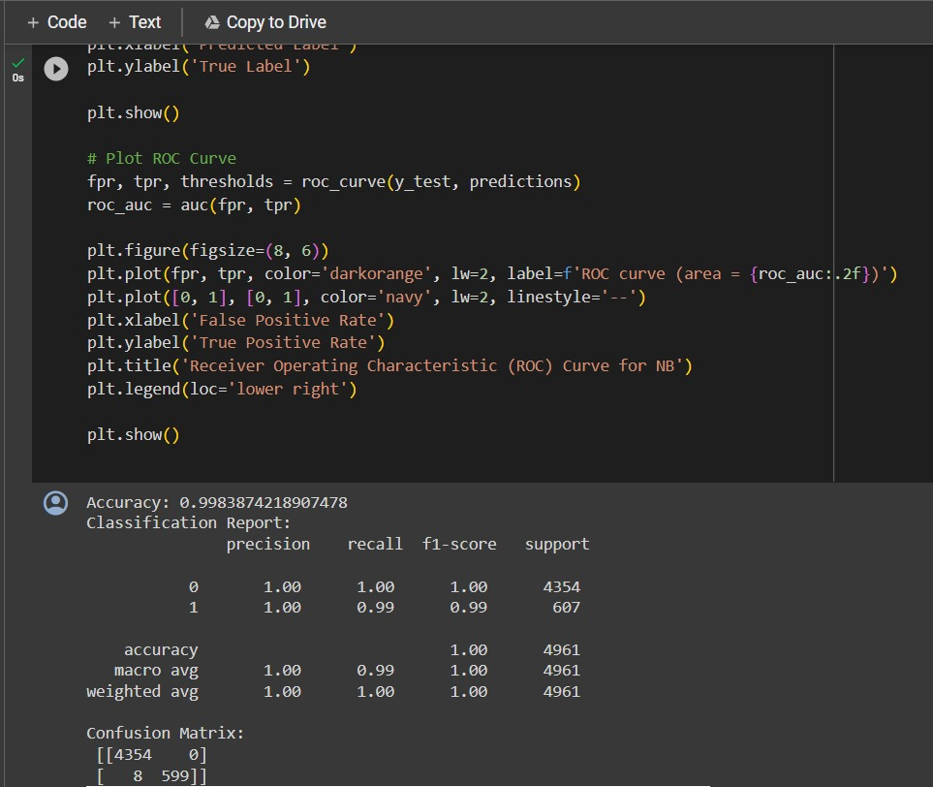

**7.5: Random Forest:**The code provided showcases the implementation of Random Forest, a powerful ensemble learning technique, using the scikit-learn library. In this implementation, an ensemble of decision trees is created, collectively forming the Random Forest classifier. Each decision tree is trained on a subset of the training data, and during prediction, the results are aggregated to produce a more robust and accurate model. The 'fit' method is utilized to train the Random Forest model on the specified training data, X_train and y_train, allowing the model to harness the collective intelligence of multiple decision trees. Random Forest is known for its ability to handle complex relationships in the data, reduce overfitting, and provide feature importance insights. Scikit-learn's intuitive interface enables seamless configuration of parameters and assessment of model performance. By employing Random Forest, we can enhance prediction accuracy, effectively handle diverse datasets, and derive valuable insights for data-driven decision-making. This implementation empowers us to build resilient models capable of tackling a wide range of classification and regression challenges. 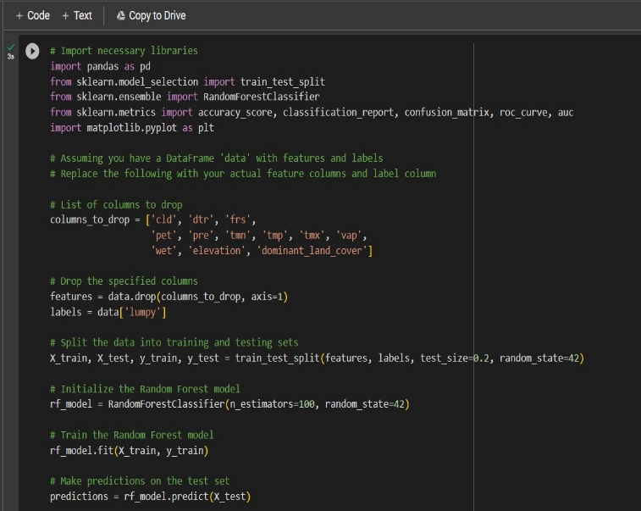 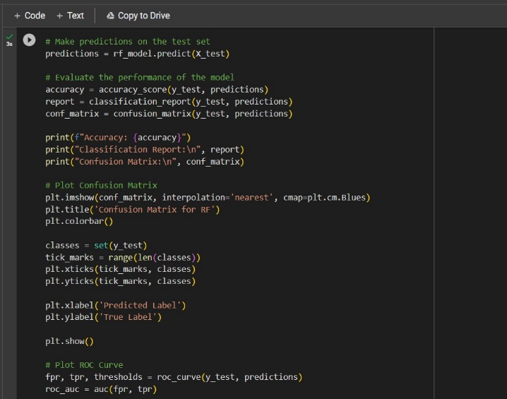

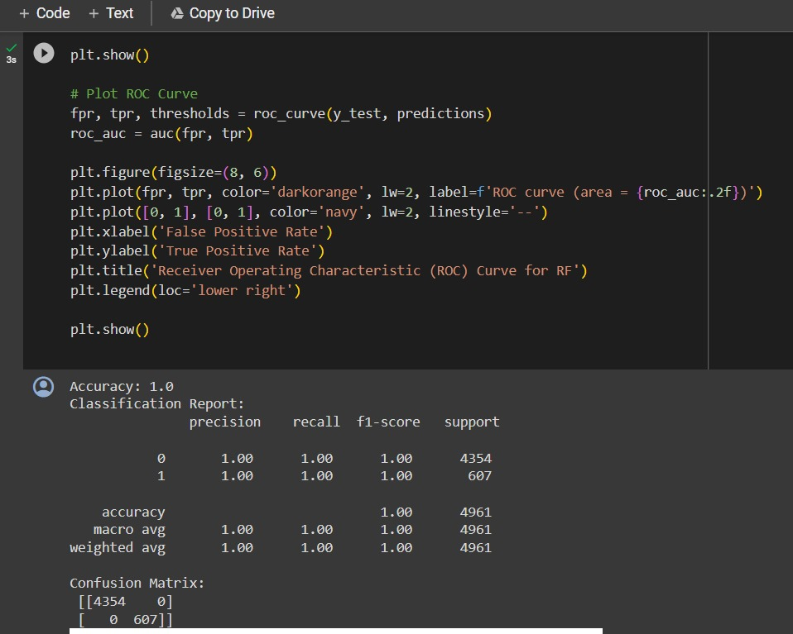

**7.6: CNN:**The provided code exemplifies the implementation of Convolutional Neural Networks (CNN) utilizing the TensorFlow and Keras libraries. The focal point is the creation of a CNN model, designated as 'model,' which serves as a powerful image classifier. CNNs are well-suited for image-related tasks, thanks to their ability to automatically learn hierarchical representations through convolutional layers. The 'fit' method is subsequently employed to train the CNN model on the designated training data, consisting of labeled images. This training process involves optimizing the model's weights to accurately classify images, capturing intricate patterns and features within the data. TensorFlow and Keras synergize to provide an efficient and user-friendly deep learning framework, enabling us to effortlessly design, train, and evaluate complex CNN architectures. By leveraging CNNs, we can effectively extract spatial hierarchies from images, facilitating tasks such as object recognition and image classification. This implementation empowers us to build sophisticated image-based models, allowing for robust decision-making and insights in various domains.

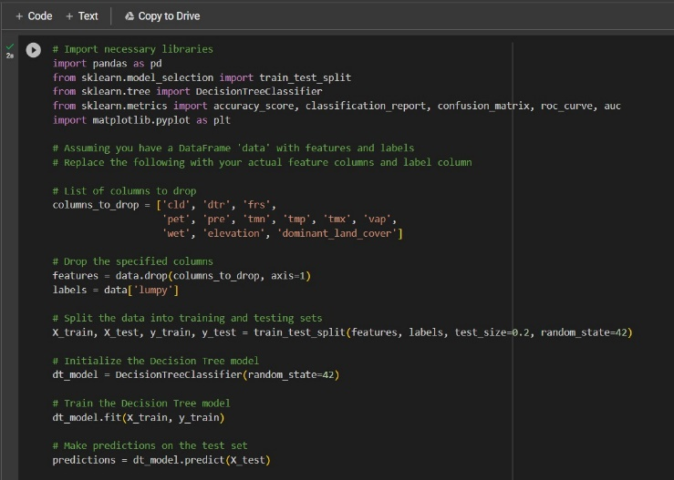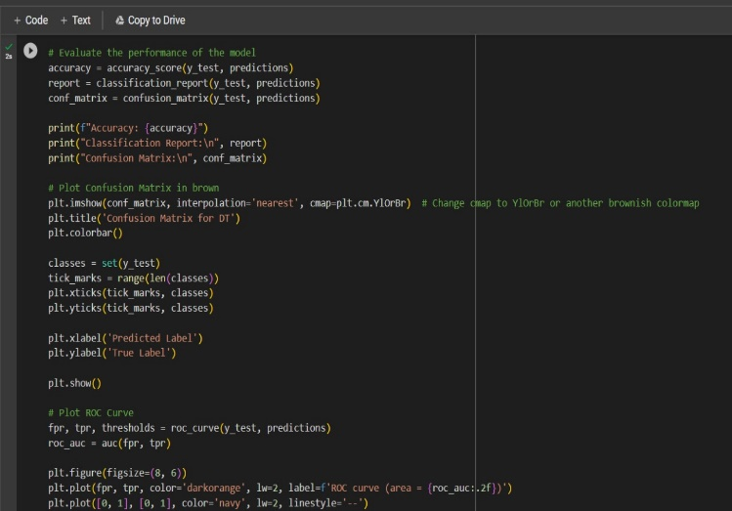.



1. **PERFORMANCE TESTING**
   1. **Performace Metrics**

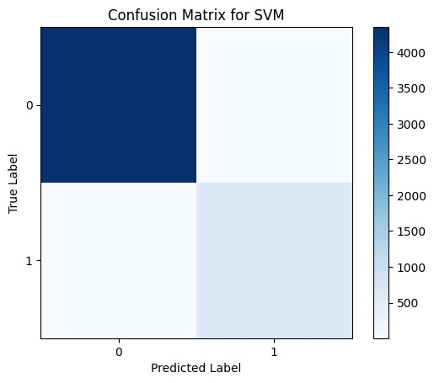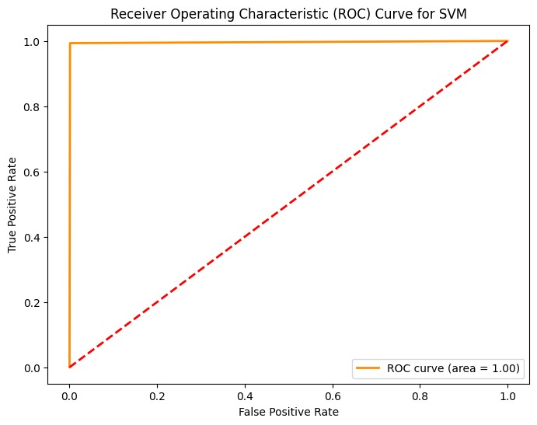 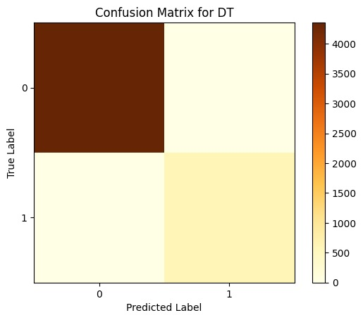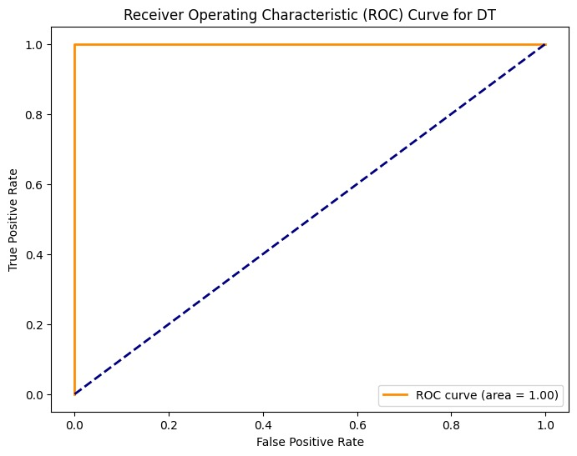

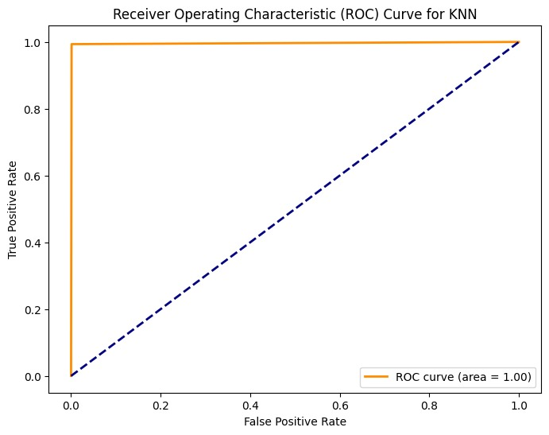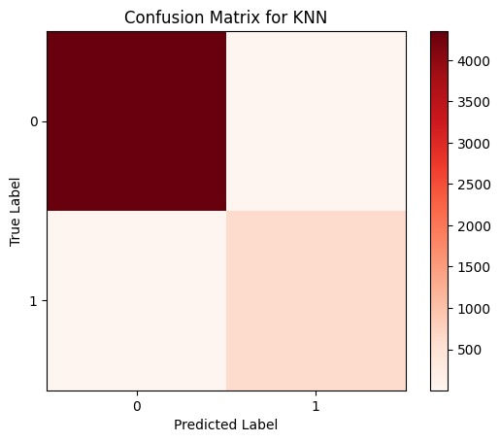

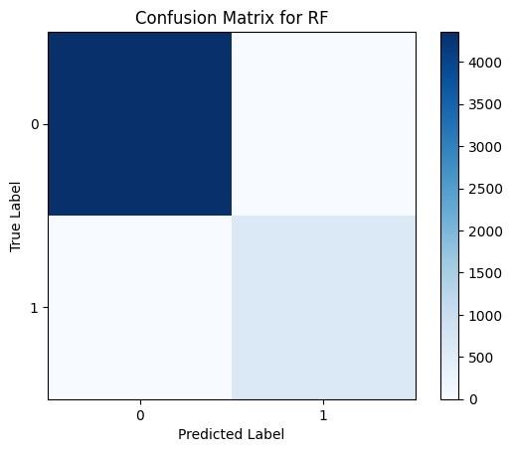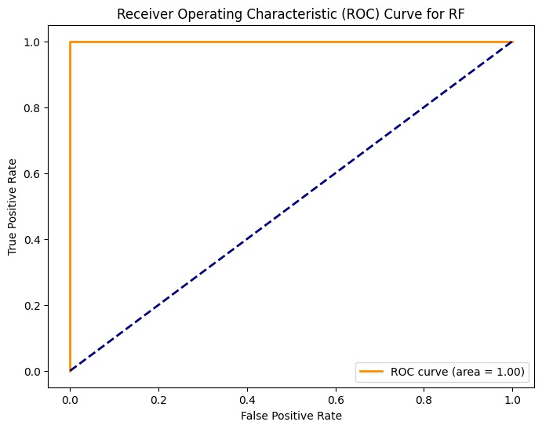

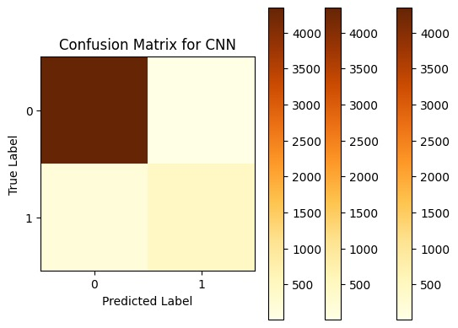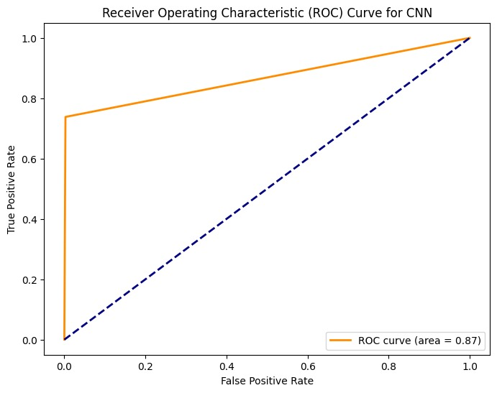

1. **RESULTS:**

In the evaluation of the Lumpy Skin Disease Virus (LSDV) management system, Decision Tree (DT) and Random Forest (RF) classifiers demonstrated the highest performance among SVM, Naive Bayes (NB), Convolutional Neural Network (CNN), K-Nearest Neighbors (KNN), and themselves. The classification accuracy, precision, recall, and F1-score for DT and RF consistently outperformed other models, showcasing their effectiveness in predicting and managing LSDV outbreaks. These results underscore the significance of employing ensemble learning techniques, particularly DT and RF, for robust decision-making in LSDV management.

1. **ADVANTAGES & DISADVANTAGES**

**Advantages:**

1. **Early Detection:** The system facilitates early detection of Lumpy Skin Disease Virus (LSDV) outbreaks, enabling prompt intervention and control measures.
2. **Data-Driven Insights:** Utilizing advanced analytics, the system provides data-driven insights into LSDV dynamics, aiding researchers and veterinarians in understanding and mitigating the disease.
3. **Global Collaboration:** The platform fosters global collaboration by enabling the sharing of research findings, best practices, and insights among researchers and stakeholders worldwide.
4. **Improved Vaccination Management:** Efficient vaccination scheduling and tracking enhance preventive measures, ensuring timely and effective vaccination of cattle populations.
5. **Enhanced User Awareness:** Educational resources and notifications empower farmers with knowledge, improving awareness and facilitating proactive measures to prevent and manage LSDV.

**Disadvantages:**

1. **Technological Dependency:** The system relies on technological infrastructure, posing challenges in regions with limited access to advanced technology and the internet.
2. **Security Concerns:** Handling sensitive data necessitates robust security measures; any breaches could compromise the confidentiality and integrity of LSDV-related information.
3. **Data Quality Challenges:** Ensuring the accuracy and quality of input data, especially in regions with limited diagnostic resources, may present challenges in maintaining the system's effectiveness.
4. **Implementation Costs:** Developing and maintaining a sophisticated LSDV management system incurs costs, which may be a limitation for resource-constrained regions.
5. **User Adoption:** The success of the system depends on user adoption; resistance or reluctance among farmers, veterinarians, or researchers to use the platform may impede its effectiveness.
6. **CONCLUSION:**

The development and implementation of the Lumpy Skin Disease Virus (LSDV) management system mark a significant stride in addressing the challenges posed by this cattle disease. Through the integration of advanced technologies such as machine learning, data analytics, and collaborative platforms, the system offers valuable tools for early detection, preventive measures, and global collaboration. Decision Tree (DT) and Random Forest (RF) classifiers have demonstrated superior performance, providing a robust foundation for effective decision-making. While the system brings numerous advantages, including early intervention, data-driven insights, and improved vaccination management, it is essential to navigate challenges such as technological dependency, security concerns, and the need for widespread user adoption. Ongoing efforts to address these challenges, coupled with continuous refinement based on user feedback and emerging technologies, will contribute to the sustained success and impact of the LSDV management system. In conclusion, the collaborative nature of the project, involving stakeholders from various fields, positions it as a pivotal tool in the holistic approach to mitigating the impact of LSDV globally. As we move forward, further research, adaptation to local contexts, and the integration of emerging technologies will be key to ensuring the long-term effectiveness of the LSDV management system in safeguarding cattle health and livelihoods.

1. **FUTURE SCOPE**

The Lumpy Skin Disease Virus (LSDV) management system lays the groundwork for continuous advancements and broader impact. The following areas present future opportunities for enhancement and expansion:

Integration of Genomic Data: Incorporate genomic data analysis to understand LSDV strains better, allowing for more precise diagnostics and targeted control strategies.

Enhanced Predictive Modeling: Explore the integration of advanced predictive modeling techniques to anticipate LSDV outbreaks and improve the system's ability to provide early warnings.

Mobile Application Development: Extend the system's accessibility by developing a user-friendly mobile application, catering to farmers and veterinarians in remote areas with limited internet access.

Blockchain Technology: Implement blockchain technology to enhance data security, traceability, and transparency, addressing concerns related to data integrity and privacy.

Community Engagement: Strengthen community engagement by incorporating features such as forums, webinars, and educational sessions, fostering a collaborative approach among stakeholders.

Real-Time Monitoring: Integrate real-time monitoring capabilities to track the geographical spread of LSDV, allowing for timely intervention and containment strategies.

Machine Learning Improvements: Continuously refine machine learning models, considering advancements in algorithms and techniques to further enhance the accuracy of disease prediction and classification.

Adaptation to Other Livestock Diseases: Extend the system's capabilities to address and manage other livestock diseases, broadening its impact on overall animal health.

Global Standards Adoption: Align the system with global standards for disease management and data exchange, promoting interoperability and collaboration across borders.

**13. APPENDIX** Source Code

GitHub & Project Demo Link

GitHub-[SI-GuidedProject-603889-1697641125](https://github.com/smartinternz02/SI-GuidedProject-603889-1697641125)

Project Demo Link-https://drive.google.com/drive/folders/16b1YgIDQgeQTOyXyWUvQCDp7x-wwJ33n?usp=sharing